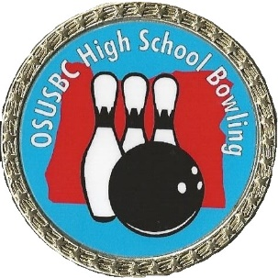
ENTRY DEADLINE: ENTRY DEADINE: JANUARY 14, 2024

2024 OREGON STATE HIGH SCHOOL BOWLING CHAMPIONSHIPS

Sponsored by Oregon State United States Bowling Congress (OSUSBC)
District Tournament –Check in by 8:30 am, Competition at 9:00 am
(See schedule for location, date, & manager contact – this form also used for State if your team qualifies)

LATE OR INCOMPLETE entries will not be accepted!
Complete entire entry - type or print all information. Submit complete entry with check payable to OSUSBC High School Program.

ENTRY FEE: $200 per team ($170 expense, $30 Scholarship), per tournament. Scholarships returned 100% and are managed by USBC SMART, Account #9453.
TEAM: Each high school may enter as many girls and/or open teams as they wish. Maximum roster is 8 players. Only 1 open and 1 girls’ team per school may advance to state.
Coach Background Check & SafeSport Training Verification – REQUIRED!
- The United States Bowling Congress (USBC) Registered Volunteer Program – copy of your current certificate or letter/email from USBC Headquarters.
Proof of background check & SafeSport Training must be submitted with entry form.
BOWLER ELIGIBILITY: Players must be eligible for other sports and activities at the High School. Bowlers must be enrolled at their school to participate and 5th year seniors are not eligible for competition. Schools will no longer be required to sign off the entry form to show eligibility.

OSUSBC District Managers will keep record of coaches’ background verification on hand at all OSUSBC certified tournaments.

Coach Name: __________________________________________ Phone: _________________________ High School: _______________________________

Coach Address: ____________________________________________ City: _______________________ State: __________________ Zip: _______________

HIGH SCHOOL |  |  |  |  | OPEN |  |  | GIRLS
TEAM ROSTER |  | ADDRESS | CITY |  |  | ZIP | PHONE |  |  | Graduation Year |  |  | Birthday  mm/dd/yyyy

Bowler 1

USBC Membership: |  | Email

Bowler 2

USBC Membership: |  | Email

Bowler 3

USBC Membership: |  | Email

Bowler 4
USBC Membership: |  | Email

Bowler 5
USBC Membership: |  | Email

Bowler 6
USBC Membership: |  | Email

Bowler 7
USBC Membership: |  | Email

Bowler 8
USBC Membership: |  | Email
COACH |  |  |  | Email

