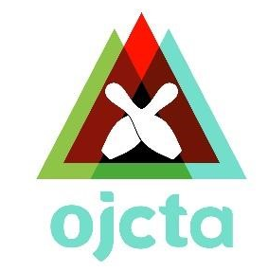
AND

Team Up Again for a
Special Doubles & Singles Event!
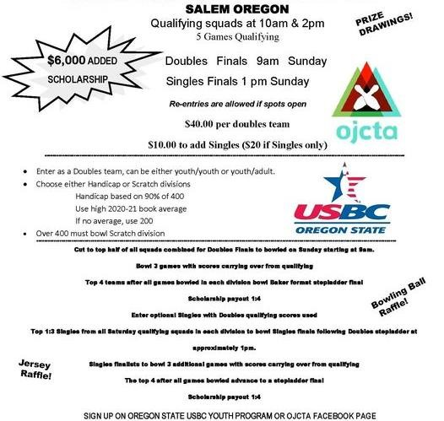
August 6-7, 2022 AMF Firebird Lanes

-

Questions? Call Gary at (503) 995-4705 or Rebecca at (503) 621-7275

