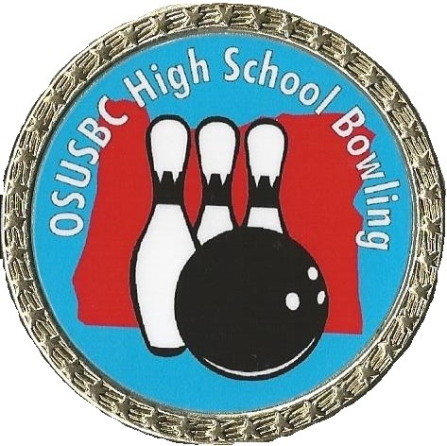

OREGON STATE

UNITED STATES BOWLING CONGRESS (OSUSBC)

2019-2020

HIGH SCHOOL BOWLING MANUAL
Dated 07/02/2019

Table of Contents
District Map 4
District Tournament Dates and Sites 5
Advancement to State Finals 5
State Finals Tournament Information 5
DISTRICT AND STATE FINALS COMPETITION RULES 6
1. TEAM ELIGIBILITY: 6
2. TEAM ROSTER: 6
3. TEAM MEMBER SELECTION: 6
4. LINEUP & TOURNAMENT PACE: 6
5. SUBSTITUTIONS: 7
6. HANDICAP: 7
7. DISTRICT TOURNAMENT COMPETITION FORMAT: 7
7a. STATE TOURNAMENT COMPETITION FORMAT: 7
8. COACHES & SCOREKEEPERS: 7
9. ENTRY FEES: 7
10. AWARDS: 8
DISTRICT COMPETITION: 8
STATE FINALS COMPETITION: 8
11. ATTIRE: 8
12. TARDY PLAYERS: 8
13. PROTESTS: 8
14. TOURNAMENT MANAGEMENT: 8
15. SPORTSMANSHIP: 8

District Map

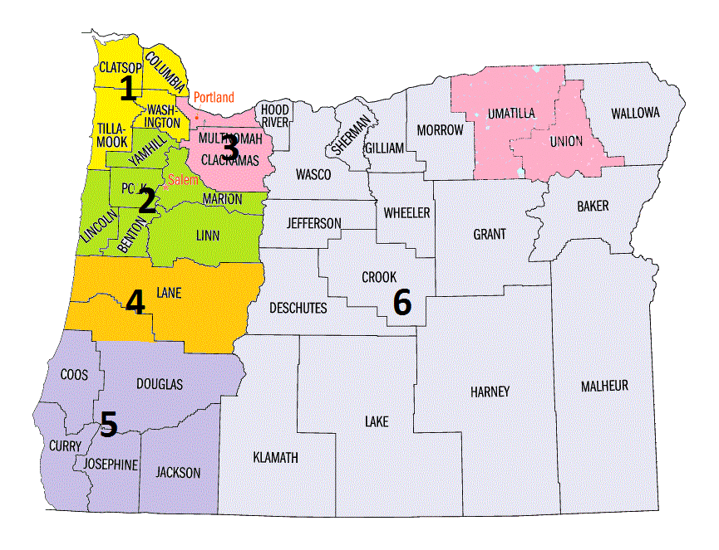

District Tournament Dates and Sites
 | Date | Location
District #1 | January 25th-26th | Superplay – Beaverton, OR
District #2 | January 18th | Town and Country – Salem, OR
District #3 | January 19th | Kellogg Bowl – Milwaukie, OR
District #4 | January 26th | Firs Bowl – Eugene, OR
District #5 | January 25th-26th | Roxy Ann Lanes – Medford, OR
District #6 | January 26th | Epicenter - Klamath Falls
District #7 | Rolled into District #3 for the 2019-2020 Season

Advancement to State Finals
Number of teams advancing by District is determined by the 2018-19 District Tournament team participation.
 | Advancing Girls Teams | Advancing Boys Teams
District #1 | 2 | 3
District #2 | 3 | 3
District #3 | 3 | 2
District #4 | 3 | 3
District #5 | 3 | 3
District #6 | 2 | 2
District #7 | 0 | 0

State Finals Tournament Information
Date: February 22nd & 23rd, 2020
Location: Firebird Lanes
4303 Center St NE
Salem, OR 97301
(503) 581-1697
Check-In Begins: 10:00am Team’s assigned check-in time will be based on when State Final Entry is received. Early entries get later team check in times.

DISTRICT AND STATE FINALS COMPETITION RULES

1. TEAM ELIGIBILITY: Players must be enrolled in grades 9 - 12 from the same High School (Unless an Co-op application has been approved). All participants (Coaches, Scorekeepers & Players 18 years and older must complete Safesport Training to be able to participate.
Exceptions: 1. In the case of a High School having grades 10 - 12 only, a player in grade 9 in a middle school may bowl on the team from the school where they will attend grade 10.
2. In the event a player attends home school or a private school that does not have its own bowling team, they may bowl for the public school within who's attendance boundaries they reside. In a school district that does not have specific attendance boundaries, the player must bowl for the high school closest in proximity to their primary residence.
Entry is open to all players that qualify for a spot on the school team. If the bowler is USBC sanctioned in the youth division, they are eligible for USBC awards they earn. Their own local USBC association must apply for the award. Players who hold adult division USBC cards are not eligible to participate.
2. TEAM ROSTER: Teams shall have a playing strength of five (5) with a maximum of eight (8) players on the roster. Boys and girls will bowl in separate divisions. No co-ed teams allowed. Legal lineup is one (1). If a team is short one or more players, it may still compete, though the coach must declare before competition, which frames will be bowled by the players for the duration of the tournament. Absentee players will receive zero for all frames. All rules applicable to full teams also apply to teams with less than five (5) players.
3. TEAM MEMBER SELECTION: A fair and impartial method will be used to select team players. No one may be excluded from the team except for the following reason(s):
1. Bowling ability
2. Sportsmanship
3. Academic deficiency Player participation is based on the following guidelines:
Due to recent changes at some of the Districts we are returning to the 2.0 minimum grade point average as of the last official grading cycle or sign off by school. In cases where the school will not sign off on the entry form Coaches may sign the form but must be able to prove the participants eligibility with their most recent completed report cards at the time of competition. Bowlers must be enrolled at their school to participate and 5th year seniors are not eligible for competition. Players attending an alternative school recognized by the high school he/she would otherwise attend must be seeking their high school diploma. No other criteria may be used.
Where outside sponsorship is obtained, sponsorship cannot affect team membership. For example, if a bowling center
sponsors a team, the team cannot be limited to bowlers from the sponsor center.

Multiple teams from a school may enter the District Tournament but only one (1) boys' team and one (1) girls' team from the same high school will be allowed at the State Finals. When multiple teams from the same high school compete in the District Tournament and the high school earns a berth at the State Finals it is the coach’s discretion (following the guidelines above) on how he/she selects the team to compete at state.

4. LINEUP & TOURNAMENT PACE:
LINEUP: A block is baker-style bowling made up of two (2) matches. A match is made up of two (2) Baker Games. After a match has started, no lineup changes except for substitutions are allowed.
PACE: Team must keep pace with opposing team player by player; player 1 may not start his/her frame until player 1 of the opposing team is up to bowl; player 2 may not start his/her frame until player 2 of the opposing team is up
5. SUBSTITUTIONS: A team may substitute a player at any time (including mid-frame) during the competition but the player removed may not return to the lineup until the next Baker block. Scores bowled through the efforts of more than one player shall not qualify for USBC awards or tournament individual records.
6. HANDICAP: All scores will be scratch; no handicap will be used.
7. DISTRICT TOURNAMENT COMPETITION FORMAT: This is a team tournament only - all baker style.
Qualifying: Twenty (20) Baker games with total pin fall determining position standings. The top six (6) boys and the top six (6) girls’ teams will advance to the semi-finals. No more than three (3) boys / girls teams from a school may advance to the semi-finals. There is no pin fall carryover to the semi-finals.
Semi-finals: One practice ball per player on each lane of your starting pair will be allowed. Ten (10) games of baker. The top three (3) boys and girls teams will advance to the finals except for District (‘s) where a fourth team qualifying team was awarded. Teams will be assigned starting lanes from their position standing after the qualifying round.
Finals: One practice ball on each lane. Finals are to be bowled on the same pair of lanes. Stepladder style using Baker game format, two (2) games per match. See the Advancement to State Finals Section to see how many High Schools will advance to the State Finals. A total of 32 teams to compete at state.
Ties: All ties will be decided by a one game Baker roll-off. If a tie still exists, a 9th & 10th frame roll-off with Coach deciding who will be their two players.
7a. STATE TOURNAMENT COMPETITION FORMAT: This is a team tournament only - all baker style.
Practice: 10 minutes practice prior to the first baker block each day, one ball on each lane of your starting pair before resuming competition after scheduled breaks. One practice ball on each lane allowed prior to each team's first match during Double Elimination finals. Teams waiting on the conclusion of the consolation bracket finals will be allowed to warm-up on a separate pair of lanes once the second game of the current match has begun.
Saturday Qualifying: 24 Baker games. All teams advance to Sunday qualifying and double elimination finals.
Sunday Qualifying & Double Elimination: Six (6) games of qualifying then two (2) - game baker double elimination finals. Total pin fall after 30 baker games of qualifying will determine seeding and lane assignments for double elimination. First place vs. 16th, Second place vs. 15th, Third place vs. 14th, etc.
Ties: All ties will be decided by one baker game roll-off. If a tie still exists, 9th and 10th frame roll-off with the Coach deciding who will be their two bowlers.
8. COACHES & SCOREKEEPERS: ALL COACHES MUST SHOW PROOF OF BACKGROUND CHECK THROUGH USBC REGISTERED VOLUNTEER PROGRAM OR BY THE HIGH SCHOOL FOR WHICH THEY COACH All participants (Coaches, Scorekeepers & Players 18 years and older must complete Safesport Training to be able to participate. Each team may have the immediate 5 players and one coach in the settee area with them, subs and one assistant coach allowed if area permits. Scorekeepers will have a designated chair on the concourse and may be allowed in the settee area at the tournament manager's discretion. Scorekeepers may not intimidate players.
9. ENTRY FEES: $180.00 per team ($150 expense, $30 scholarship). Checks to OSUSBC High School Program. No Cash

10. AWARDS:
DISTRICT COMPETITION: Team awards for 1st, 2nd and 3rd in boys' and girls' divisions. Individual medals and certificates for all finalists.
DISTRICT ALL STAR TEAM MEMBERS, MVP: The top five (5) boys and five (5) girls, based upon All Star point total through the qualifying games (MUST BOWL MINIMUM OF 32 FRAMES) at the District tournament will earn first right to participate in the State All Star Tournament. The top boy and girl in each district will be named the most valuable player and earn a $75 scholarship; runner-up in each division will receive a $50 Scholarship. Each district's All Star Teams will receive District All Star Team Certificates at the tournament and be given their All Star Tournament entries.
STATE FINALS COMPETITION: Participating certificates to all team members. Team awards for 1st, 2nd, and 3rd place. Individual Scholarships and medals for 1st, 2nd, and 3rd place teams. First Place Champions and All-Star members will receive sweatshirts. Scholarships will be managed by SMART, OSUSBC High School Bowling Account #9453.
STATE FINALS ALL STAR TEAM SELECTION: The top five (5) boys and girls with the All Star point average (MUST BOWL MINIMUM OF 48 FRAMES) will be named to the 2018 State All Star team based on the following point system: Strikes - 3 points, Spares - 2 points. Eleventh and twelfth frames will not count. The boy and girl with the highest point average will be named Most Valuable Players and earn $100 scholarships. Players must bowl at least 40 frames to be eligible; All Star points will be accumulated through the 30 Baker Games of Qualifying.
11. ATTIRE: Players must wear a clean and pressed shirt / blouse with collar. Non-collared shirts are not permitted. Girls are to wear slacks, dress cords, or shorts provided the inner seam length of the shorts are at least six (6) inches. Boys are to wear slacks, dress shorts or dress cords. No undergarments showing. Absolutely no holes, patches or frayed hems will be allowed. HATS, OVERALLS and JEANS OF ANY TYPE WILL NOT BE ALLOWED! Tournament committee reserves the right to determine appropriate attire. DRESS CODE ALSO APPLIES TO COACHES AND SCOREKEEPERS IN THE CONCOURSE/SETTEE AREA. SCOREKEEPERS IN VIOLATION OF THE DRESS CODE WILL NEED TO SIT IN THE SPECTATOR AREA.
SHIRT LETTERING; The name of the school is to be on the back of the shirt / blouse. Sponsor identification is limited to the upper sleeve or over the pocket. Bowlers name may be placed on the back at shoulder level to allow for dual use.
12. TARDY PLAYERS: Tardy players will take a ZERO for missed frames. Players absent when it is their turn to bowl will receive ZERO for missed frames, unless they have received permission from a tournament official.
13. PROTESTS: Protests must be filed with a tournament official prior to the next step of competition.
14. TOURNAMENT MANAGEMENT: Tournament committee and tournament manager will make decisions on matters not covered by USBC or tournament rules and policies.
15. SPORTSMANSHIP: Foul language (verbal or written), inappropriate gestures, intentional fouls, and abusive behavior toward equipment or people will not be allowed by any participating player, coach or scorekeeper for the duration of the tournament. This will be announced at the start of competition. No other warnings will be given. Violators will be subject to penalties as defined in Rule 6 Oregon High School Bowling Rules and will not be eligible for any awards. In addition, teams must not move into the playing area of other teams until those teams have finished their match. Cheering is strongly encouraged provided it is not done with the intent to distract others while they are up to bowl. No artificial noisemakers allowed. Only the player currently up to bowl will be allowed on the approach. Players are not required to sit down while competing.
High School Bowling Competition begins at team check-in and ends after the award ceremony. Any violation of the rules during the time frame regardless if the player is competing or not could result in loss of any awards or invitations received during competition.

